**Airbnb: Vacation Rentals, Cabins, Houses.**



**Session: 2021**

**Submitted by:**

**Noman Ahmad 2021-SE-24**

**Wali Muhammad 2021-SE-39**

**Supervised by:**

**Ma’am Zahra**

**Sir Zeeshan**

Department of Computer Science, New Campus **University of Engineering and Technology Lahore, Pakistan**

Table of Contents

Abstract 3

Introduction 3

Objective 3

Problem Statement 4

Tools and Technology 5

Scope and Vission 5

Related Work 6

Timeline/Gantt Chart 8

Wireframes 9

Functional Requirements 15

Non-Functional Requirements 16

UML Diagrams 18

Test Cases 23

Group Detail 27

Abstract

Our project will connect people who want to rent out their homes with people who are looking for accommodations in specific area. Our Project will be a web portal.

Airbnb increases supply of short-term travel accommodations and slightly lower prices.

The Objective of our project is to offer people an easy, relatively stress-free way to earn some income from their property and to provide guests feel like they are in home rather in a hotel.

As traveling is a part of life. Our project will be very beneficial in future also.

## Introduction

Airbnb is an online marketplace and hospitality service, aiding users to rent or lease accommodation not limited to bed and breakfasts, hostels, homestays, apartments, rooms or hotels for short period of time.[1]

This website is easy to use that a lay man can use it to book residential areas. The website allows its clients to book hotels, apartments, flats, rooms for any number of guests, for a short duration of time. The user can also register as a “Host” to rent their houses and rooms for other people using Airbnb.

Lahore is known as one of Pakistan’s most populated city, and it has a lot of Airbnb’s hotels, apartments and flats to serve the user’s any time. With Airbnb, the Lahore housing market is transferred to short-term rentals. Airbnb is trying to make its service more fast and more efficient.

## Objective

Airbnb’s objective is to**create a world where anyone can belong anywhere** and we are focused on creating an end-to-end travel platform that will handle every part of your trip. As we work to achieve this goal, we are focused on building for the future, driving strong sustained growth, and creating new businesses that will power long-term success.[2]

## Problem Statement

* Time Issue

This application will save a lot of time of user. The user doesn’t need to go for booking. He/she need an active internet connection to use the application and book the hotel at his/her desire location.

* Get rid of long Queue

Usually, people go physically to book a hotel. In popular hotel, the people face a long queue and they have to wait a long time to request for a room. This application has resolved this issue. The user can book the hotel by one click and get rid of long queue.

* Expensive Hotels

As the Elite class hotels require more money, Airbnb provide users good and first-class hotels and apartment at discount rate. Airbnb has connection over many hotels and it also provides some discount packages for user in First class and Ordinary hotels and residential places.

* Better Hosts

Hosts in local hotels and apartments are usually not good and have a rough behavior. In Airbnb, your host will give you real local tips and comfort of all things unlike the other hotels and residential places.

* First Check then Book

The people who do not want to visit ever hotel before booking can use Airbnb. This application provides user to take a look at the hotel and check the reviews before booking the hotel. So, he\she can book the hotel according to his/her taste.

* Larger group can stay

The application is especially useful for those people which travels with their families. Airbnb provide user to book a tiny house or apartment so the people can live with family instead of booking two or more rooms in hotel. It makes user feel more at home when your whole family gets to stay together. Some Airbnb even have dinning rooms to fit your whole family at a table.

|  |
| --- |
| Create a world where anyone can belong anywhere |

**Tools and Technology**

The major tool used in this Project are software based. The whole website is made on HTML, CSS and Bootstrap.

* **HTML and CSS**

HTML is used to create the basic structure of website. CSS is used to add Styling in the website. The CSS is mainly used in Classes of color used in Bootstrap in website Navbar and in indentation.

* **Bootstrap**

Bootstrap is a free and open-source CSS framework directed at responsive web development. It contains HTML, CSS and JavaScript-based design templates for different components like Navbar, Scroller, Buttons, Cards and responsive images.

**Scope and Vision**

* **Scope**

This website will provide service of booking hotels, apartments and villas anywhere in the world using Credit card, Debit card.

* **Vision**

The Airbnb vision explanation is “Have a place Anywhere.” The vision articulation discusses going past the local and public impediment with regards to the administrations any customer can get from Airbnb. Airbnb is among the principal organizations to come out emphatically in making the world a worldwide town. The magnificence of this web is that regardless of being broad, it stays strong in the headway of the Airbnb idea of unity. Thus, this has made an assorted worldwide network with recognizing Airbnb attributes and encouraged by the comprehensive stage that all the hosts and visitors misuse regardless of their area.[3]

**Related Work**

This project is similar to the [Outdoorsy](http://www.outdoorsy.com) & [Booking.com](http://www.booking.com) , that provide the facility to accommodate recreational vehicles (campervans, coaches etc.).

* **Booking.**[**com**](http://www.booking.com)

While Airbnb has attracted a lot of attention in the hospitality and travel industry over the past couple of years, before the home-sharing platform rose to dominance it was [Booking.com](https://www.booking.com/index.en-gb.html?label=gen173nr-1DCAEoggI46AdIM1gEaCeIAQGYAQm4AQfIAQ3YAQPoAQGIAgGoAgO4AoSMoecFwAIB;sid=8b3caa195bb4d6f8e4847aa8ff6c8f0c;keep_landing=1&sb_price_type=total&) that was dominating the online accommodation sector originally.[4]

**Booking.com provides online reservation services.** We act as an intermediary (agent) between guests wanting to make an accommodation reservation and your hotel, property or temporary/holiday rental.[5]

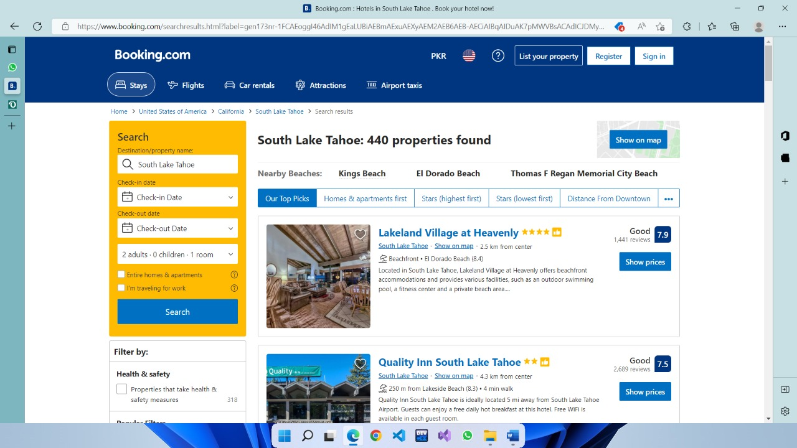

* [**Outdoorsy**](http://www.outdoorsy.com)

The introduction to Outdoorsy is, Outdoorsy is a marketplace platform that connects RV owners with other campers. Outdoorsy is an online platform where motorhome owners and renters come together in one place. Owners can rent out their trailers when they’re not using them.[6]

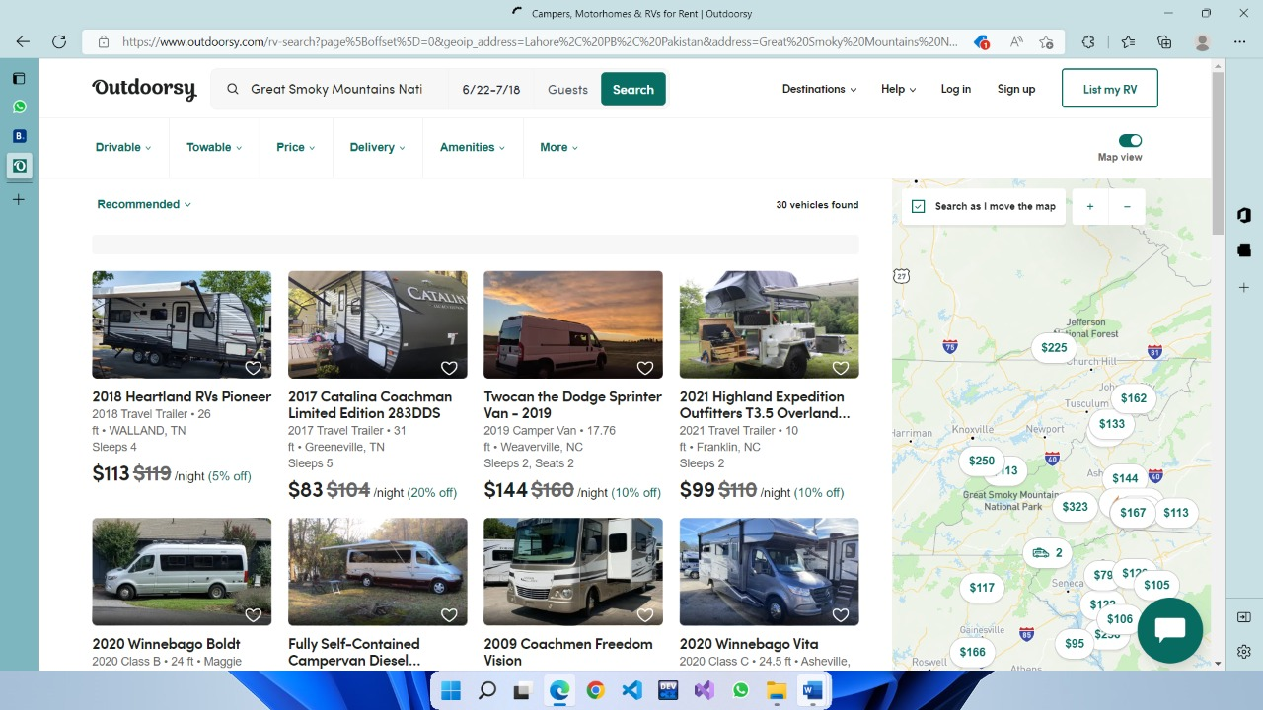

## Timeline/Gantt Chart

In first 2 weeks, we will work on Requirements. In 3th-4th week, we will work on HTML and 4th-5th week we will work on CSS. Next, the 5th-6th week we will work on Bootstrap. After the coding, we will work on Testing in 5th to 6th week and in last week we will work on website proposal and documentation.

|  |  |  |  |  |
| --- | --- | --- | --- | --- |
| Project | Week 1-2 | Week 3-5 | Week 5-6 | Week 6-7 |
| Requirements |  |  |  |  |
| HTML & CSS |  |  |  |  |
| Bootstrap |  |  |  |  |
| Testing |  |  |  |  |
| Documentation |  |  |  |  |

## Wireframes

* **Home Page**

T2

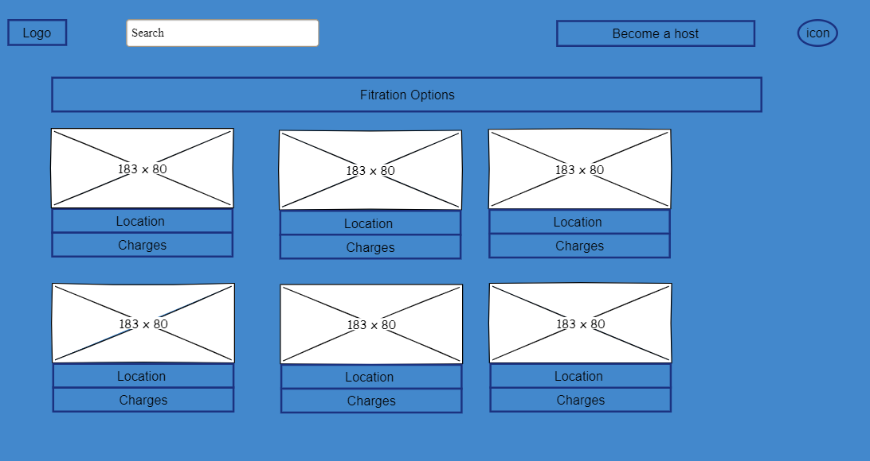

T5

T4

T3

T1

|  |  |
| --- | --- |
| User | Admin |
| **T1:** As a user, I shall be able to search for any location. | **T1:** As an admin I shall manage the search results. |
| **T2:** As a user, I shall be able to become a host for renting out residential places. | **T2:** As an admin, I shall allow the user to become a host for renting out residential places. |
| **T3:** As a user, I shall be able to login or sign up my account. | **T3:** As an admin, I shall manage the login details of the users. |
| **T4:** As a user, I shall be able to apply filter according to my requirements. | **T4:** As an admin, I shall manage the results according to filter. |
| **T5:** As a user, I shall be able to view the listing of recommended residential places. | **T5:** As an admin, I shall display the most visited residential places to the user. |

* **Login or sign in Modal**

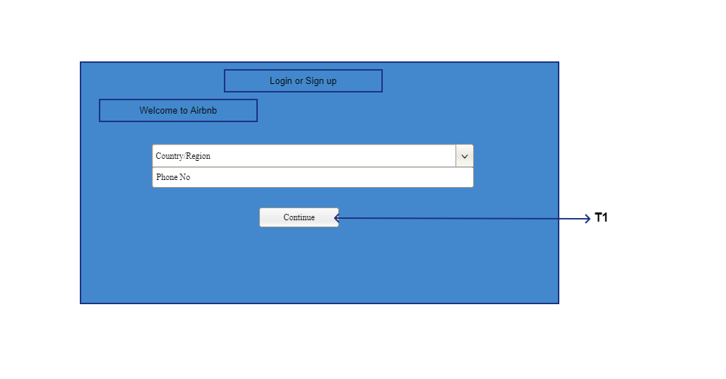

|  |  |
| --- | --- |
| User | Admin |
| **T1**: As a user, I shall be able to login to my account. | **T1:** As an admin, I shall manage login details. |

* **Sign up Modal**

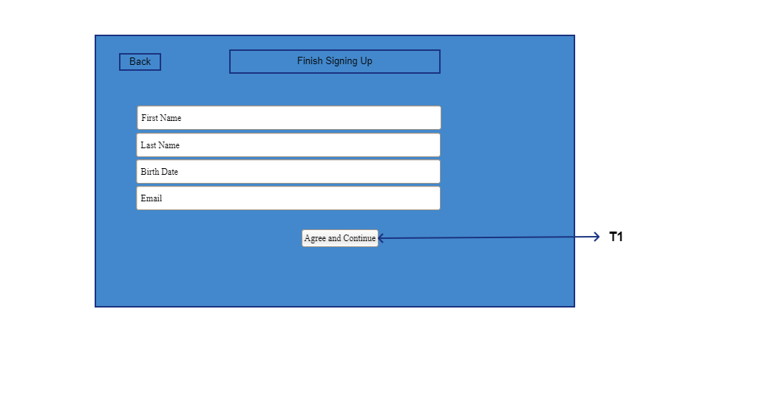

|  |  |
| --- | --- |
| User | Admin |
| **T1**: As a user, I shall be able to create a new account. | **T1**: As an admin, I shall store the account details. |

* **Hosting Page**

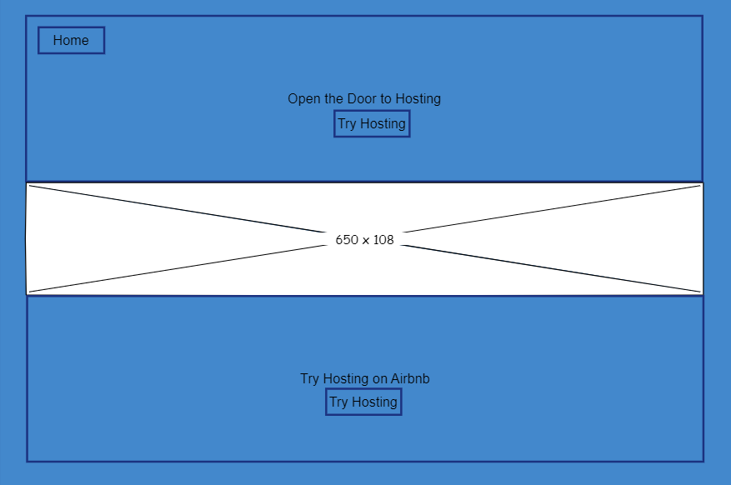

T2

T1

|  |  |
| --- | --- |
| User | Admin |
| **T1**: As a user, I shall be able return to home page. | **T1**: As an admin, I shall allow the user return to home page. |
| **T2:** As a user, I shall be able to become a host for renting out residential places. | **T2:** As an admin, I shall allow the user to become a host for renting out residential places. |

* **Search Page**

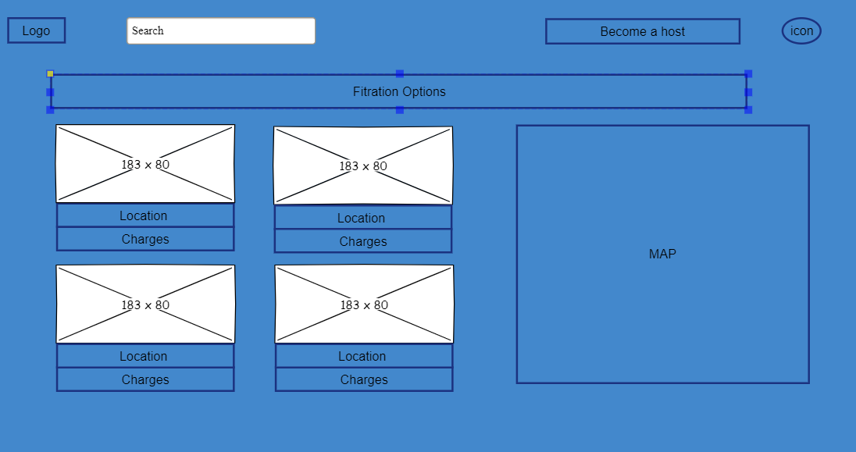

T3

T5

T2

T4

T1

|  |  |
| --- | --- |
| User | Admin |
| **T1:** As a user, I shall be able to search for any other location. | **T1:** As an admin I shall manage the search results. |
| **T2:** As a user, I shall be able to become a host for renting out residential places. | **T2:** As an admin, I shall allow the user to become a host for renting out residential places. |
| **T3:** As a user, I shall be able to login or sign up my account. | **T3:** As an admin, I shall manage the login details of the users. |
| **T4:** As a user, I shall be able to apply filter according to my requirements. | **T4:** As an admin, I shall manage the results according to filter. |
| **T5:** As a user, I shall be able to view the search results. | **T5:** As an admin I shall display the search results. |

* **Product Page**

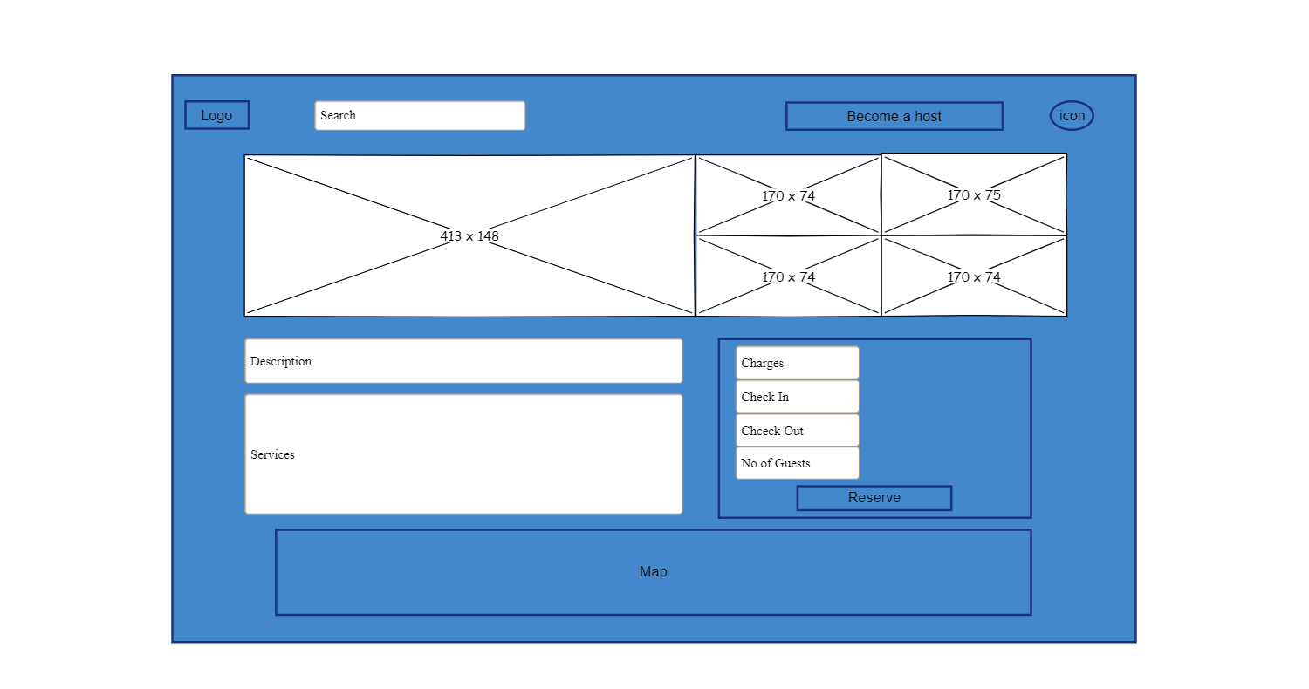

T4

T3

T2

T1

|  |  |
| --- | --- |
| User | Admin |
| **T1:** As a user, I shall be able to search for any other location. | **T1:** As an admin I shall manage the search results. |
| **T2:** As a user, I shall be able to become a host for renting out residential places. | **T2:** As an admin, I shall allow the user to become a host for renting out residential places. |
| **T3:** As a user, I shall be able to login or sign up my account. | **T3:** As an admin, I shall manage the login details of the users. |
| **T4:** As a user, I shall be able to reserve/book the residential area. | **T4:** As an admin, I shall check the availability and allow the user to book the residential area. |

* **Payment Page**

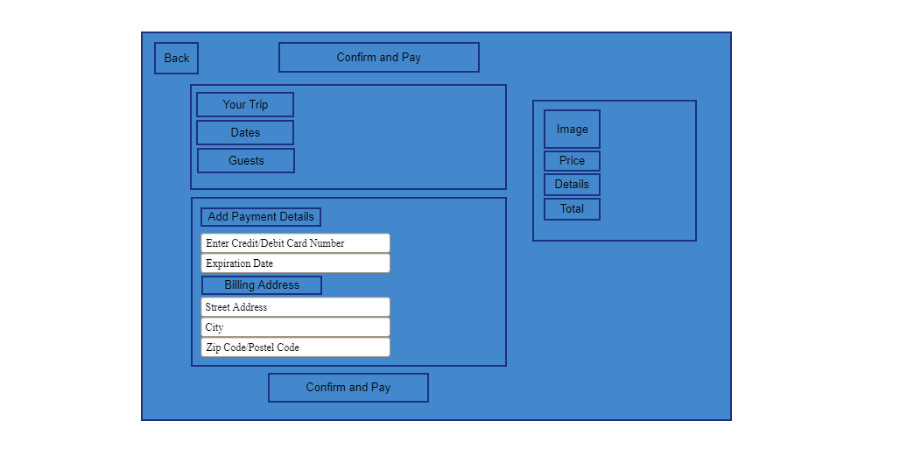

T1

|  |  |
| --- | --- |
| User | Admin |
| **T1:** As a user, I shall be able to add payment method and pay for reservation. | **T1:** As an admin, I shall verify the payment method and reserve the hotel for the user. |

* **Confirmation Page**

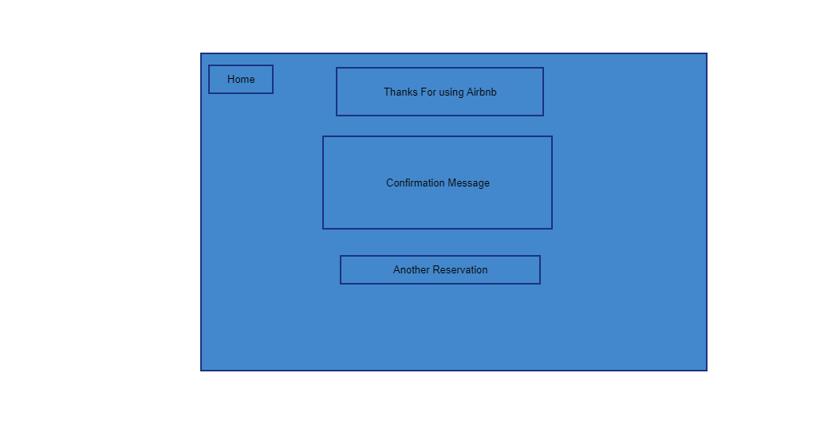

T11

|  |  |
| --- | --- |
| User | Admin |
| **T1:** As a user, I shall be able to reserve another booking. | **T1:** As an admin, I shall allow user to reserve another booking. |

# Functional and Non-Functional Requirements

## Functional Requirements

* The tourist shall be able to search for a particular location.
* The tourist shall be able to view all the homes, flats available for the particular area.
* The tourist shall be able to view all the facilities available at the particular home / flat.
* The tourists shall be able to book flat after signing in their account.
* The tourists shall be able to see all their previous bookings.

|  |  |  |
| --- | --- | --- |
| Employee Badge | Gears | Handshake |

* The tourists shall be able to review their experience when they checkout.
* The tourist shall be able to make payment of the booking of home / flat.
* The tourist shall be able to view all the pictures of the flat.
* The tourist shall be able to book the flat for more than 1 day.
* The co-host shall be to view all his listings.
* The co-host shall be able to mark his listing as unavailable, in case the flat is booked.
* The co-host shall be able to manage (add, edit or delete) his listings.
* The co-host shall be able to receive his payments online.
* The co-host shall be able to see all previous and future bookings of his flat.

## Non-Functional Requirements

|  |  |
| --- | --- |
| * Performance Requirement * The response time for booking a flat must be from 1 to 5 seconds. * The project must provide a throughput of 50 requests at a time. * The project must be able to view 10 listings on 1 page. * Scalability Requirements * The system must able to handle listings of up to 25 cities. * Capacity Requirements: * The system must be able to handle 500 users at a time. * The system must be able to handle listing of 10 cities. * It must respond 1000 users at a time. * Availability Requirements * The service must be provided 24/7. * The system must be available at 365 Days in a Year. * In case of any mishap or emergency users must be notified at least 1 day before the unavailability of service. * Maintainability Requirements * The system must be easy to understand so that it can be easily repaired or improved. * Security Requirements * The system should be secure. It should provide security against ethical hacking. * Every check-in and check-out detail of last 30 days must be stored. * The information of every user and co-host must be stored. * Regularity Requirements * The system must follow the rules and regulations of the government. * It must not share the personal data of its user with someone else. * Manageability Requirements * The system must be easily manageable. It should be easy to add or remove any data in the system. * Data Integrity Requirements * If any transaction is made, it must be updated in the database. * Useability Requirements * The system must be easy to understand, the user with color blindness must be able to easily view and understand the system. * Interoperability Requirements * The system must be self-explained, i.e., when we hover over any button, it must explain its purpose. |  |
| * Performance Requirement * The response time for booking a flat must be from 1 to 5 seconds. * The project must provide a throughput of 50 requests at a time. * The project must be able to view 10 listings on 1 page. * Scalability Requirements * The system must able to handle listings of up to 25 cities. * Capacity Requirements: * The system must be able to handle 500 users at a time. * The system must be able to handle listing of 10 cities. * It must respond 1000 users at a time. * Availability Requirements * The service must be provided 24/7. * The system must be available at 365 Days in a Year. * In case of any mishap or emergency users must be notified at least 1 day before the unavailability of service. * Maintainability Requirements * The system must be easy to understand so that it can be easily repaired or improved. * Security Requirements * The system should be secure. It should provide security against ethical hacking. * Every check-in and check-out detail of last 30 days must be stored. * The information of every user and co-host must be stored. * Regularity Requirements * The system must follow the rules and regulations of the government. * It must not share the personal data of its user with someone else. * Manageability Requirements * The system must be easily manageable. It should be easy to add or remove any data in the system. * Data Integrity Requirements * If any transaction is made, it must be updated in the database. * Useability Requirements * The system must be easy to understand, the user with color blindness must be able to easily view and understand the system. * Interoperability Requirements * The system must be self-explained, i.e., when we hover over any button, it must explain its purpose.  UML DiagramsUML diagrams are visual representation of the system. It shows the classes, function and the working of the system. UML diagrams required for the project are given:  * **Class Diagram**    Test Cases |  |

|  |  |  |  |  |  |  |  |  |  |  |
| --- | --- | --- | --- | --- | --- | --- | --- | --- | --- | --- |
| **Test Case ID** | | AB_001 | **Test Case Description** | | Test the login functionality of Airbnb | | | | | |
| **Created By** | | Wali Muhammad | **Reviewed By** | | Ma’am Zahra | | **Version** | | 1.1 | |
|  |  |  |  |  |  |  |  |  |  |  |
| **Tester's Name** | | Numan | **Date Tested** | | 20-Jun-2022 | | **Test Case (Pass/Fail/Not Executed)** | | Pass | |
|  |  |  |  |  |  |  |  |  |  |  |
| **S #** | **Prerequisites:** | | |  | **S #** | **Test Data** | | | | |
| 1 | Access to Chrome Browser | | |  | 1 | Sign up using customer credentials | | | | |
| 2 | Access to internet | | |  | 2 | Sign in to existing account using username and password | | | | |
| 3 | Access to Home page of site | | |  |  |  | | | | |
|  |  |  |  |  |  |  |  |  |  |  |
| **Test Scenario** | Verify moving back to Home Page and change country | | | | | |  |  |  |  |
|  |  |  |  |  |  |  |  |  |  |  |
| **Step #** | **Step Details** | | **Expected Results** | | **Actual Results** | | | **Pass / Fail / Not executed / Suspended** | | |
|  |
| 1 | Navigate to http://www.Airbnb.com | | Site should open | | As Expected | | | Pass | | |  |
| 2 | Selecting dropdown user accounts | | Sign in and log in buttons appear | | As Expected | | | Pass | | |  |
| 3 | Select sign up to move to sign in modal. | | Modal appear representing sign in functionality | | As Expected | | | Pass | | |  |
| 4 | Select log in to move to sign in modal. | | Modal appear representing log in functionality | | As Expected, | | | Pass | | |  |
| 5 | Select the “become a Host” to become a host of Airbnb. | | Become a host page is shown | | As Expected | | | Pass | | |  |

|  |  |  |  |  |  |  |  |  |  |  |
| --- | --- | --- | --- | --- | --- | --- | --- | --- | --- | --- |
| **Test Case ID** | | AB_002 | **Test Case Description** | | Test the logo and searching functionality | | | | | |
| **Created By** | | Wali Muhammad | **Reviewed By** | | Ma’am Zahra | | **Version** | | 1.1 | |
|  |  |  |  |  |  |  |  |  |  |  |
| **Tester's Name** | | Numan | **Date Tested** | | 20-Jun-2022 | | **Test Case (Pass/Fail/Not Executed)** | | Pass | |
|  |  |  |  |  |  |  |  |  |  |  |
| **S #** | **Prerequisites:** | | |  | **S #** | **Test Data** | | | | |
| 1 | Access to Chrome Browser | | |  | 1 | Click site’s logo | | | | |
| 2 | Access to internet | | |  | 2 | Search for apartments, Rooms | | | | |
| 3 | Access to Home page of site | | |  |  |  | | | | |
|  |  |  |  |  |  |  |  |  |  |  |
| **Test Scenario** | Verify moving back to Home Page and search for a particular apartment | | | | | |  |  |  |  |
|  |  |  |  |  |  |  |  |  |  |  |
| **Step #** | **Step Details** | | **Expected Results** | | **Actual Results** | | | **Pass / Fail / Not executed / Suspended** | | |
|  |
| 1 | Navigate to http://www.Airbnb.com | | Site should open | | As Expected | | | Pass | | |  |
| 2 | Click logo of site | | Moved to Home page | | As Expected | | | Pass | | |  |
| 3 | Type in the required features of the apartment and press search button | | Most high rated apartments with required features appear. | | As Expected | | | Pass | | |  |
|  | | | | | | | | | | |  |

|  |  |  |  |  |  |  |  |  |  |  |
| --- | --- | --- | --- | --- | --- | --- | --- | --- | --- | --- |
| **Test Case ID** | | AB_003 | **Test Case Description** | | Test the navigation bar features | | | | | |
| **Created By** | | Wali | **Reviewed By** | | Ma’am Zahra | | **Version** | | 1.1 | |
|  |  |  |  |  |  |  |  |  |  |  |
| **Tester's Name** | | Numan | **Date Tested** | | 20-Jun-2022 | | **Test Case (Pass/Fail/Not Executed)** | | Pass | |
|  |  |  |  |  |  |  |  |  |  |  |
| **S #** | **Prerequisites:** | | |  | **S #** | **Test Data** | | | | |
| 1 | Access to Chrome Browser | | |  | 1 | Selecting Design | | | | |
| 2 | Access to internet | | |  | 2 | Selecting Arctic | | | | |
| 3 | Access to Home page of site | | |  | 3 | Selecting shared homes | | | | |
|  |  |  |  |  |  |  |  |  |  |  |
| **Test Scenario** | Verify moving back to Home Page and search for a particular apartment | | | | | |  |  |  |  |
|  |  |  |  |  |  |  |  |  |  |  |
| **Step #** | **Step Details** | | **Expected Results** | | **Actual Results** | | | **Pass / Fail / Not executed / Suspended** | | |
|  |
| 1 | Navigate to http://www.Airbnb.com | | Site should open | | As Expected | | | Pass | | |  |
| 2 | Select Design from the navigation bar | | Different apartments, rooms and cabin shown as cards | | As Expected | | | Pass | | |  |
| 3 | Select Arctic from the navigation bar | | Apartments in the northern areas are shown as cards | | As Expected | | | Pass | | |  |
| 4 | Select shared homes | | Apartments having family size space are shown as cards | | As Expected | | | Pass | | |  |
|  | | | | | | | | | | |  |

|  |  |  |  |  |  |  |  |  |  |  |
| --- | --- | --- | --- | --- | --- | --- | --- | --- | --- | --- |
| **Test Case ID** | | AB_004 | **Test Case Description** | | Test the cards functionality | | | | | |
| **Created By** | | Wali | **Reviewed By** | | Ma’am Zahra | | **Version** | | 1.1 | |
|  |  |  |  |  |  |  |  |  |  |  |
| **Tester's Name** | | Numan | **Date Tested** | | 20-Jun-2022 | | **Test Case (Pass/Fail/Not Executed)** | | Pass | |
|  |  |  |  |  |  |  |  |  |  |  |
| **S #** | **Prerequisites:** | | |  | **S #** | **Test Data** | | | | |
| 1 | Access to Chrome Browser | | |  | 1 | Select the required card to reserve | | | | |
| 2 | Access to internet | | |  | 2 | Enter the day & date to reserve and the no of guests to reside | | | | |
| 3 | Access to Home page of site | | |  | 3 | Choose the location on map | | | | |
|  |  |  |  |  |  |  |  |  |  |  |
| **Test Scenario** | Verify the apartments or flats have incorporated the payment and reservation functionality | | | | | |  |  |  |  |
|  |  |  |  |  |  |  |  |  |  |  |
| **Step #** | **Step Details** | | **Expected Results** | | **Actual Results** | | | **Pass / Fail / Not executed / Suspended** | | |
|  |
| 1 | Navigate to http://www.Airbnb.com | | Site should open | | As Expected | | | Pass | | |  |
| 2 | Select the required apartment, flat or rooms card | | Product page will be displayed. | | As Expected | | | Pass | | |  |
| 3 | Choose the required dates and day format and no of guests to reside | | Reserve button becomes active | | As Expected | | | Pass | | |  |
| 4 | Select reserve to move to payment options and Card credentials. | | Payment page is displayed | | As Expected | | | Pass | | |  |
| 5 | Fill the payment credentials and choose the billing address. | | Bill receipt is sent to the registered email address | | As Expected | | | Suspended | | |  |
|  | | | | | | | | | | |  |

## Group Detail

**Group Member**

* Noman Ahmad (2021-SE-24).
* Wali Muhammad (2021-SE-39).

We both worked together on Requirements, Coding (HTML, CSS, Bootstrap), Testing and website Documentation.

**The End**

1. [How Airbnb Works (investopedia.com)](https://www.investopedia.com/articles/personal-finance/032814/pros-and-cons-using-airbnb.asp#:~:text=Airbnb%20is%20an%20online%20marketplace%20that%20connects%20people,on%20an%20air%20mattress%20in%20their%20living%20room.)
2. <https://news.airbnb.com/airbnb-2019-business-update/>
3. Vision of Airbnb. [online] Available at: https://visionarybusinessperson.com/airbnb-mission-statement-vision-statement-analysis/
4. History of Booking.com: https://medium.com/keycafe/the-history-of-booking-com-cc213a735380
5. Booking.com Introduction: https://partner.booking.com/en-gb/help/working-booking/going-live/how-does-bookingcom-work-property-owners#:~:text=Booking.com%20BV%20(%E2%80%9CBooking,as%20an%20'agency%20model'.
6. [Outdoorsy Review 2022 - Looking at The Fees, Insurance, Rentals & More (thervnomad.com)](https://thervnomad.com/outdoorsy-review/)